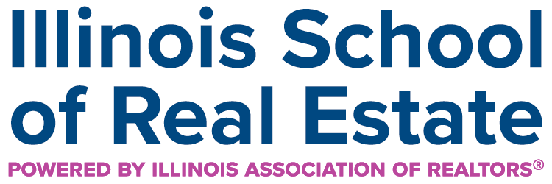
Presented by: The Group University Training Center |  |  |  |  |  | Course Date: 1/12 & 1/13, 2026
Course #: 564004135 |  |  |  |  |  | Course Time: 9a-12p, each day
Course Description : COR 1902 – 6 -hour Illinois Core  This course fulfills the Illinois Core CE requirement for licensed real estate brokers and managing brokers. It provides critical updates to the Real Estate License Act, Rules, and related legal provisions governing the practice of real estate in Illinois. Key topics include agency relationships, written brokerage agreements, compensation disclosure, fair housing compliance, escrow and earnest money procedures, advertising rules, and disciplinary actions.  The course emphasizes consumer protection, regulatory compliance, and the ethical responsibilities of licensees. It features practical scenarios, and current examples of violations and enforcement to help participants remain compliant and serve clients and the public with integrity. |  |  |  |  |  | Course Location:  Group University  The Real Estate Group, Inc  3701 W Wabash Ave  Springfield, IL 62711
 |  |  |  |  |  | Instructor: Michael D Oldenettel
Make check payable to: |  |  | The Real Estate Group, Inc.
Submit registration to: |  |  | Debbie Bilyeu
Email: |  |  | dbilyeu@thegroup.com | Phone: |  | 217-321-8107
REGISTRATION
Name: |  |  |  |  | NRDS or  License #:
Business Address:
City/State |  |  |  |  |  | Zip:
Email: |  |  |  |  |  | Phone:
If you require special accommodations due to a disability, please describe the accommodation(s) requested:

